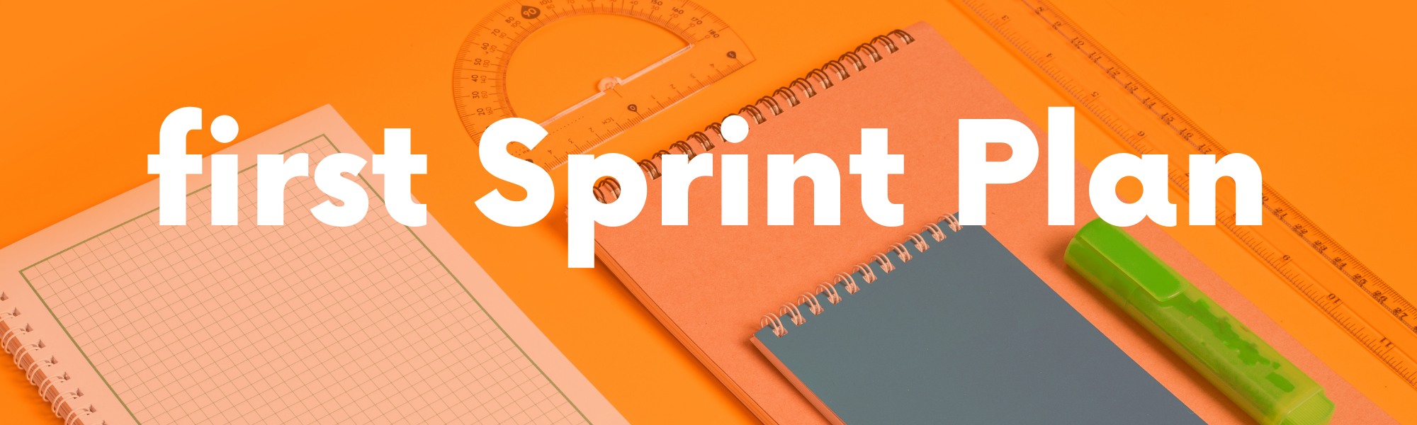

**The duration of first plan is two week and 3 days**

|  |  |  |
| --- | --- | --- |
| **tasks** | **description** | **deadline** |
| Data collection | * Determine the sources of data collection, such as we collect (photos of students, their previous attendance data), and after that we begin collecting data. | 2 days |
| Data cleaning | * unify the extension of the images by making them the same extension and the same size, remove duplicate images, link the images to the student’s data such as (student’s name and code), and improve the quality of the images. | 3 days |
| Preparing The first prototype | * adjust the angle, lighting, and place where we will place the camera * The stage of writing the code is to make this model recognize the face using the (open cv) library. * Training the project on the data after we did clean and everything * We do a test to make sure it is accurate and that there are no errors | 5 days |
| Preparing System | * We create a user interface (gui) to start showing her who attended and who did not * I link this data to a file like Excel so that the data speaks on its own automatically * We make the data more secure | 4 days |
| Final test of the project | * We are testing the project in our targeted location * We take a feedback * We will modify the project based on this video * We deliver the project | 3 days |